1. **How to prepare GooglePlay account:**

In your GooglePLay developer console select “Edit Profile”, you will be transferred on page like followed:

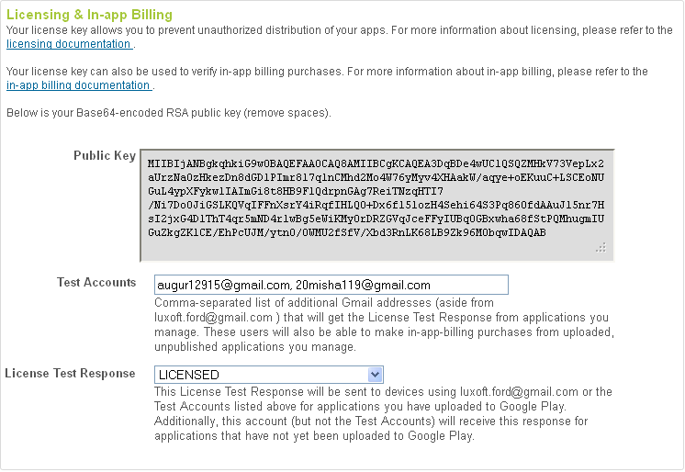

To field “Test accounts” and gmail boxes which accounts will have ability to test application.

**Important: in drop-box of the field “Information about licensing” select ”LICENSED”, otherwise application won’t be able to pass license validation.**

1. **Code base fix with Public key.**

In your GooglePLay developer console select “Change Profile”, you will be transferred on page which screenshot was provided above (pls. see item 1).

* 1. Copy provided public key to the clipboard;
  2. Open “Avatar” project in eclipse, find AvatarDownloaderService.java file and replace existed BASE64_PUBLIC_KEY value with public key from your account.

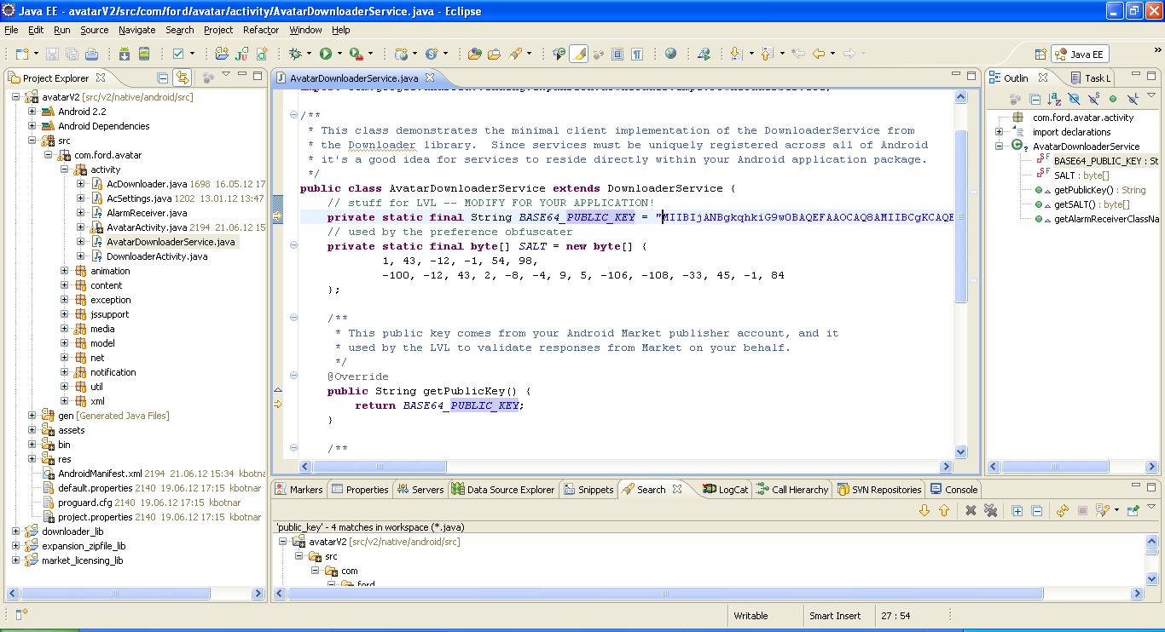

1. **Prepare apk file:**

Open project in eclipse, press mouse “right” button on project and select from context menu “Android Tools->Export Signed Application Package”

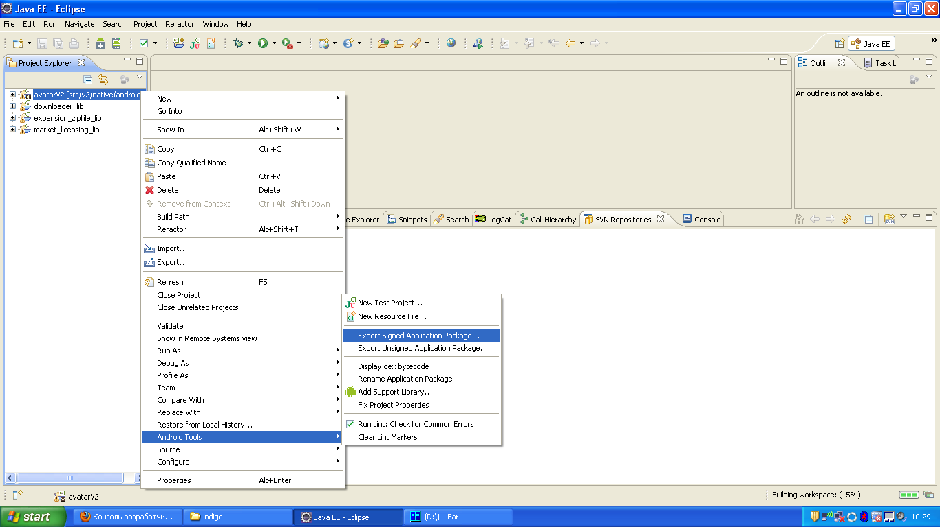

**Note:** to upload apk to GooglePlay, the apk should be signed with normal certificate (received from Google or created yourself). GooglePLay doesn’t allow upload apk files, signed with debug certificate, provided with Android-SDK.

1. **Upload apk file and extension file to the GooglePlay account:**

When the apk file is ready, please login to your GooglePLay developer console, you will have list of your applications:

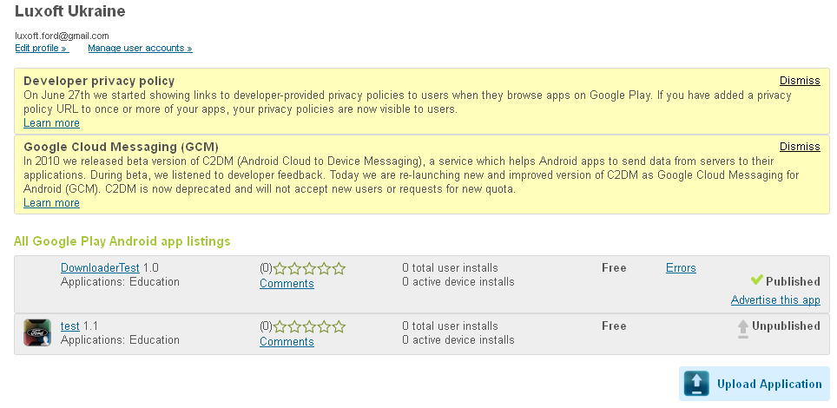

Click on the already downloaded application, in my case -“DownloaderTest 1.0”.

You will be transferred to the page where you can edit information about application, select tab “APK Files” and press the button “Upload APK”

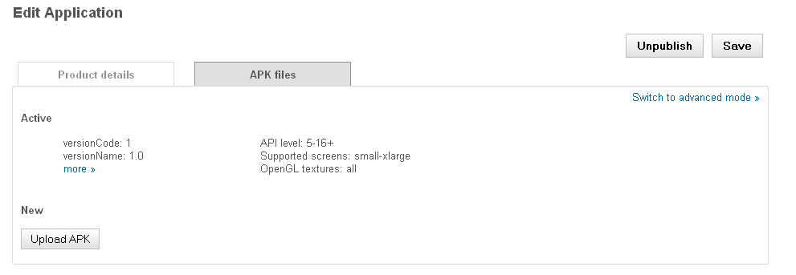

Press this button and upload the application with help of followed dialog:

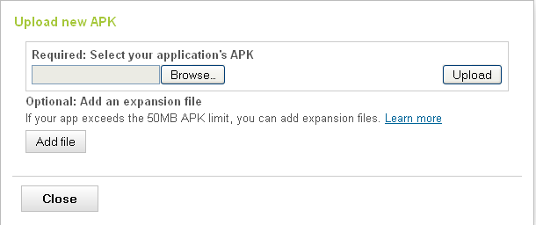

As you added APK file and extension file press button “Save”

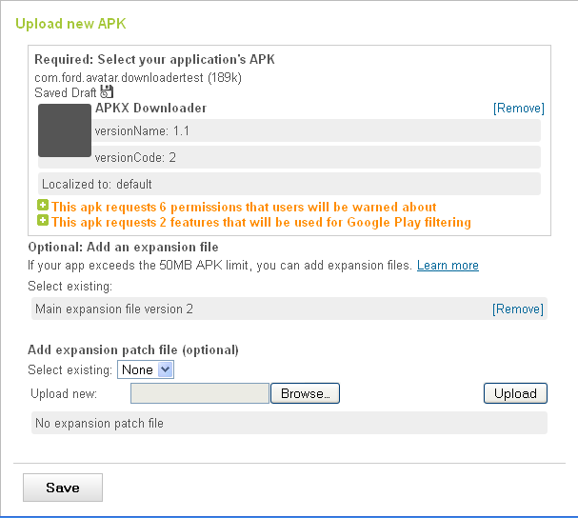

When saving will be finished you will have 2 version of application in your application tab

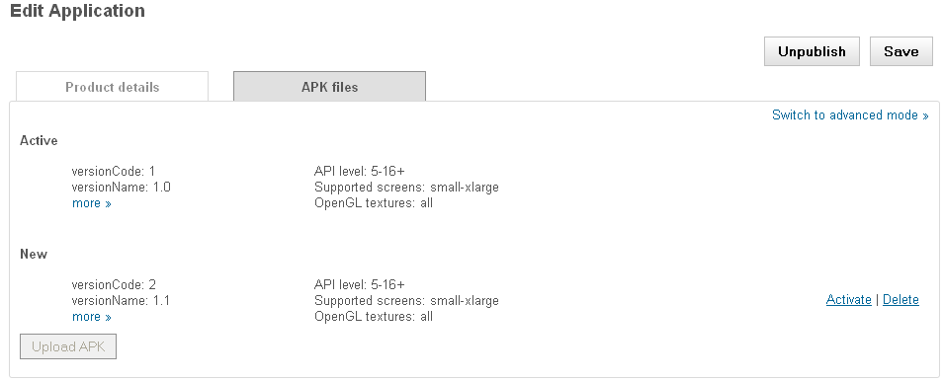

To finish uploading process press button “Save” in right-upper corner.